Methodology Report:

Visualisation & Analysis on Namma Yatri Data

Include your visualisations, analysis, results, insights, and outcomes.
Explain your methodology and approach to the tasks. Add your conclusions to the sections.
Table 1: Data Description

Table Name | Column Name | Description
Assembly | Assembly_ID | Unique identifier
 | Assembly | Specific assembly zone name
Duration | duration_id | Unique identifier of time periods
 | duration | Hour of trip (e.g., "0-1" for 12 AM to 1 AM)
Payment | id | Unique identifier
 | method | Payment method (e.g., Cash, UPI, Credit Card)
Trip Details | tripid | Unique identifier of trips
 | loc_from | Source Location code
 | searches | Trip request count
 | searches_got_estimate | Got an estimated price (1 = user gets an estimate, 0 = does not get an estimate)
 | searches_for_quotes | Searched for drivers after estimate (1 - searched, 0 - not searched)
 | searches_got_quotes | Got quotes (1 = Driver allotted, 0 = not allotted)
 | customer_not_cancelled | Whether customer cancelled or not (1 = Not cancelled)
 | driver_not_cancelled | Whether driver cancelled or not (1 = Not cancelled)
 | otp_entered | (1 = OTP entered, 0 = not entered)
 | end_ride | Whether ride was completed (1 = Completed)
Trips | tripid | Links to Trip Details
 | faremethod | Payment method ID, links to Payment table
 | fare | Fare amount
 | loc_from | Location ID of source
 | loc_to | Location ID of destination, links to Assembly table
 | driverid | Driver ID
 | custid | Customer ID
 | distance | Distance in KM from source to destination
 | duration | Unique identifier of time periods like duration_id

Points to Note:
- Without this methodology document, the other parts of your case study will not be evaluated.
- This assignment is different from the ones you have solved before.
Make sure that you treat this case study as a storytelling exercise and not an analysis/visualisation one. This will help you be better prepared for the presentations.
- Once you are done with the analysis and visualisations, there will be many insights at your hand.
Make sure that you map the right visuals and takeaways with the right audience since some of these insights might be relevant to one group but not to the other group.
- DO NOT change the text or numbering of any task, as it may cause problems with grading. Write your solutions to a task in the space provided below the respective task.

Tasks to be performed
- Present the overall approach of the analysis.
- Mention the problem statement and the analysis approach briefly.
- To solve a task, you have to create relevant visualisations and derive appropriate insights from the visualisations.
- Add all the plots, insights, calculated field commands, results and outcomes for a task with proper numbering and sequence in the report.
- The scores for all tasks (except conclusions) comprise both analysis work in the visualisation tool and its outcome in the report.
- You will be awarded a score for a task only if the Tableau/PowerBI analysis is correct and is included in the report along with the subsequent insights.
- Finally, draw conclusions based on the analysis.

Scoring:
Report Total Marks: 70
Sections: 3 sections (10 marks + 40 marks + 20 marks)

Analysis and Visualisation

1. Data Preparation [10 Marks]
- Import and Join Tables Correctly [5 Mark]
  - Import the Namma Yatri dataset into Tableau/Power BI.
  - Ensure that you correctly join all tables to create a unified dataset for analysis.
  - Verify the relationships between different tables and confirm that data from various sources is properly aligned for accurate insights.
Solution:

Created mapping between the all 5 tables from Namma Yatri dataset into Power BI with the below mapping conditions.
Trips to Assembly with Many to One cardinality on loc_from(start location) and Id
Trips to Duration with Many to One cardinality on duration column from tips and Id column from Duration table.
Trips to Payments with Many to One cardinality on faremethod column from trips and Id column from payments table.
Trips to Trips_detail with One-to-One cardinality with bi direction filter condition on trip_id from trips and Trips_detail table.
Below is the mapping screenshot from Power BI for reference.
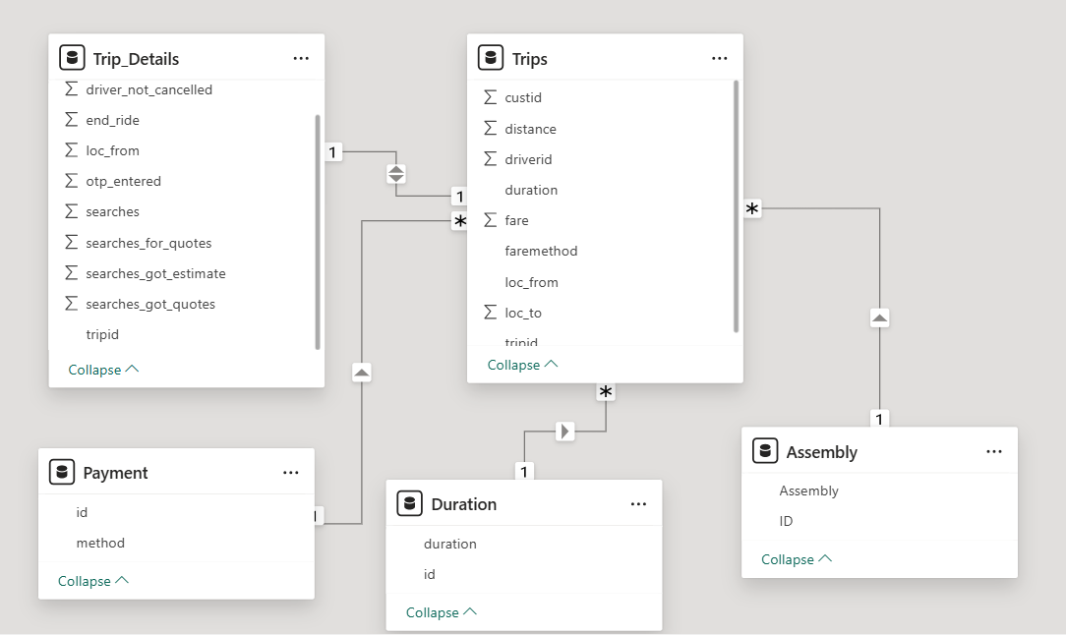

- Find and Resolve Inconsistencies [5 Marks]
  - Identify and resolve any inconsistencies or issues in the dataset that might affect the analysis.
  - Clean the data to ensure it is structured properly for analysis, removing any irrelevant, duplicate, or erroneous entries.
  - While performing the analysis, create calculated fields as needed to ensure the accuracy and relevance of the insights.
Solution:

Renamed few columns from Trip_Details table(tripid to trip_id), Trips(tripid to trip_id, faremethod to fare_method, driverid to driver_id, custid to cust_id) as it has difficult to understand.
Created fare_per_km measure using dax as below
fare_per_km = SUM(Trips[fare]) / SUM(Trips[distance])
Completed_Trips_After_Search= (CALCULATE(COUNT(Trip_Details[trip_id]),Trip_Details[searches_for_quotes]=1, Trip_Details[customer_not_cancelled]=1)) / (CALCULATE(COUNT(Trip_Details[trip_id]),Trip_Details[searches_for_quotes]=1))
Customer_Cancelled=
(CALCULATE(COUNT(Trip_Details[trip_id]),FILTER(Trip_Details, Trip_Details[customer_not_cancelled]=0)))/COUNT(Trip_Details[trip_id])
Customer not Cancelled = (CALCULATE(COUNT(Trip_Details[trip_id]), FILTER(Trip_Details, Trip_Details[customer_not_cancelled]=1)))/COUNT(Trip_Details[trip_id])
Driver Cancelled = (CALCULATE(COUNT(Trip_Details[trip_id]), FILTER(Trip_Details, Trip_Details[driver_not_cancelled]=0)))/COUNT(Trip_Details[trip_id])
Driver not Cancelled = (CALCULATE(COUNT(Trip_Details[trip_id]), FILTER(Trip_Details, Trip_Details[driver_not_cancelled]=1)))/COUNT(Trip_Details[trip_id])

2. Exploratory Data Analysis [40 Marks]
- Classify Variables into Categorical and Numerical [2 Marks]
  - Classify all the variables in the dataset into numerical and categorical types.
Solution:

Marked all variable in the dataset as numerical and categorical expect Assembly variable from Assembly table and its data category marked as place to use in map visual.

- Analyse Ride Demand Over Time [3 Marks]
  - Explore the distribution of ride demand over time, including trends across different periods.
  - Identify the peak demand periods. Choose an appropriate parameter for demand based on your own understanding.
Solution:

Below visual give the distribution of completed rides over different period of time.
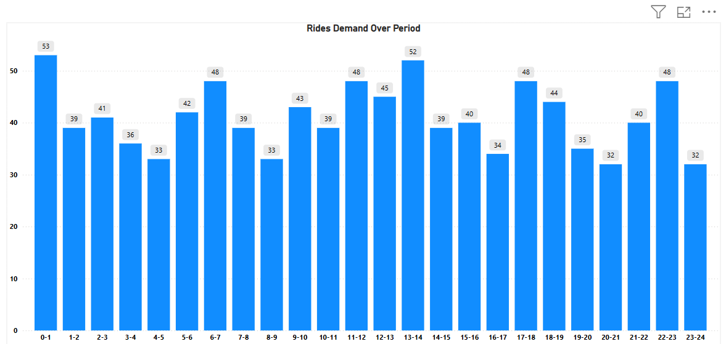
Created a group as Early Morning as duration between 12 AM to 6 AM, Morning as duration between 6 AM to 12 PM, Afternoon as duration between 12 PM to 6 PM, Evening as duration between 6 PM to 12 AM to see the demand in different parameters.
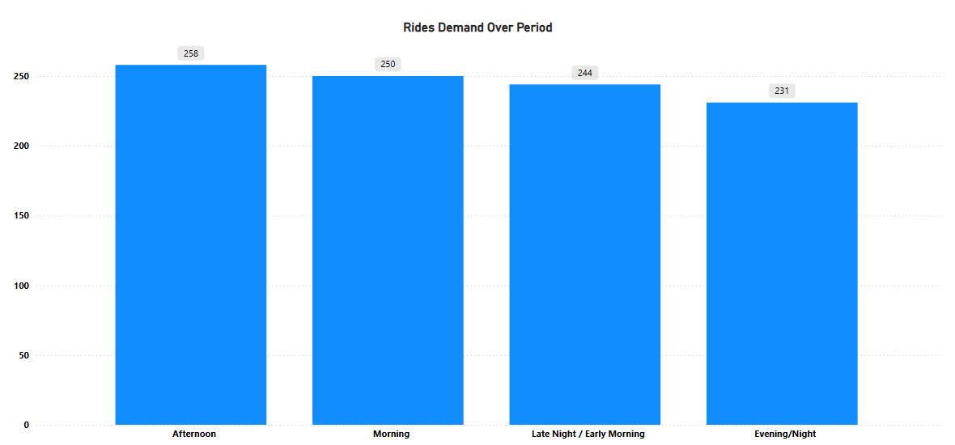
As per the above visual observed Afternoon 12 PM to 6 PM has the highest demand of overall 258 completed rides.

- Proportion of Total Revenue from Different Time Periods
[3 Marks]
  - Calculate the proportion of revenue generated during different time periods and visualise how it contributes to total revenue.
Solution:

Below visual show the revenue generated during the different time period for all completed rides.
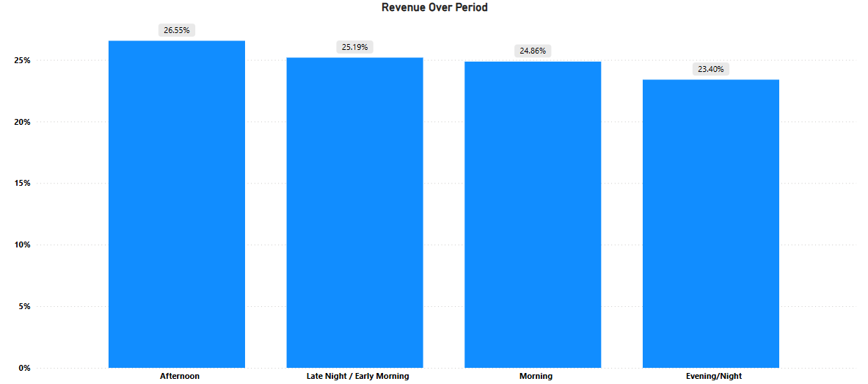
It has observed 12 PM to 6 PM has the highest revenue contribution compared with other time periods of 26.55 percent.

- Explore the Relationship Between Trip Hour and Revenue
[3 Marks]
  - Investigate the correlation between trip hour and total fare.
  - Explain any trends or patterns that emerge.
Solution:

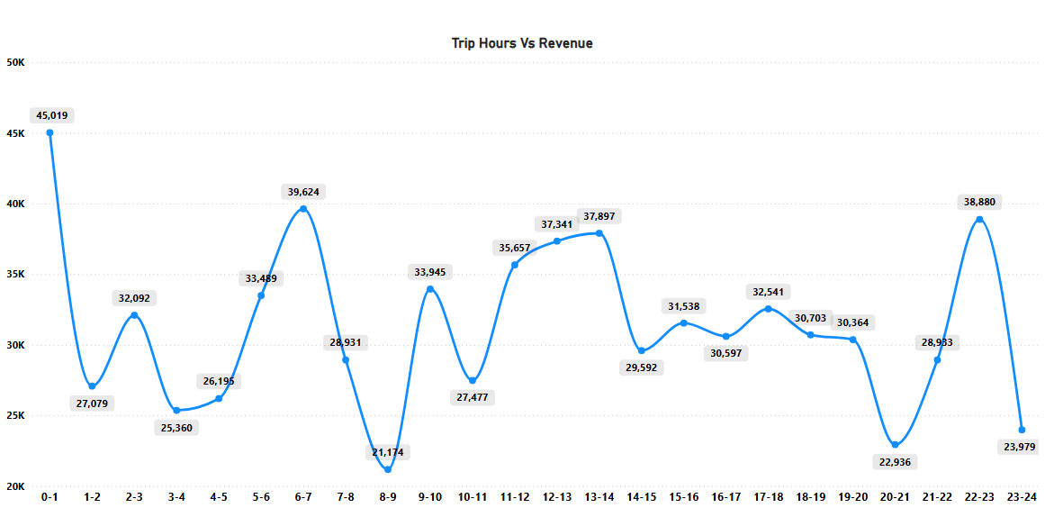
As per the above trend the correlation and patterns between completed trip hour and revenue.
High revenue hours:
- 0-1 AM the highest revenue is recorded during this time 45,019.
- 6-7 AM and 10-11 PM other peak hours with revenue 39,624 and 38,880.
- 12 PM to 2 PM steady increase with another local peak 35,657 to 37,897.
Low revenue hours:
- 8-9 AM the lowest revenue 21,174 despite being a morning hour.
- 8-9 PM another dip to 22,936 possible due to reduced demand.

- Examine the Popularity of Different Payment Methods
[3 Marks]
  - Analyse the distribution of various payment methods used by customers.
  - Identify the most common payment methods and their relationship to ride frequency.
Solution:

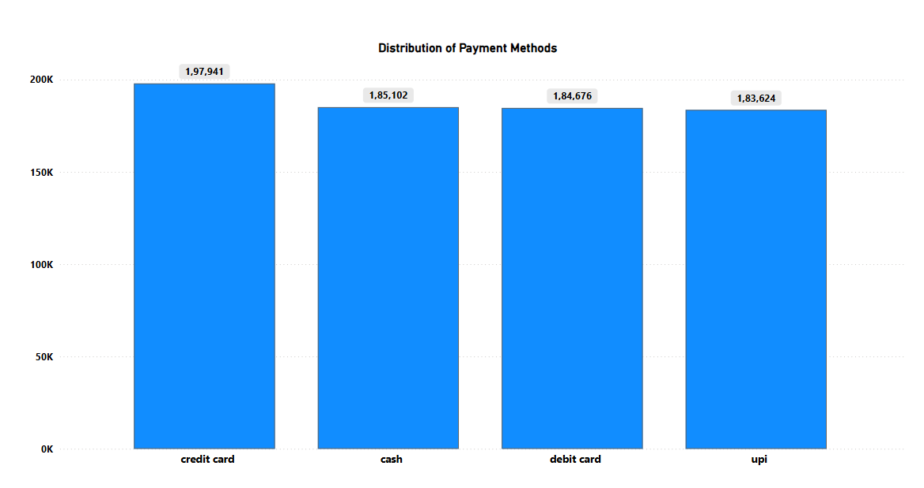

Most Preferred Method: Credit Card
- Credit card leads in total fare amount collected.
- Indicates a high adoption of credit card-based payments, possible by frequent riders.
- Suggests strong trust in digital security and app integration.
Very close Competition
- The difference between cash, debit card, and UPI is relatively minimal (1-2k difference).
- Implies a balanced adoption of various payment methods.
- This diversity may reflect user preference, availability, or app offers.
Cash Still Prominent
Despite digital transactions are high, cash remains the second most used.
Might be common among:
- Area with Poor internet connectivity.
- Spontaneous trip users.

- Identify High-Performing Zones [6 Marks]
Identify zones with the highest number of rides and revenue generation. Analyse factors contributing to their performance:
  - 2.6.1. Rides: Identify pickup zones with the highest number of trip requests.
[3 marks]
Solution:

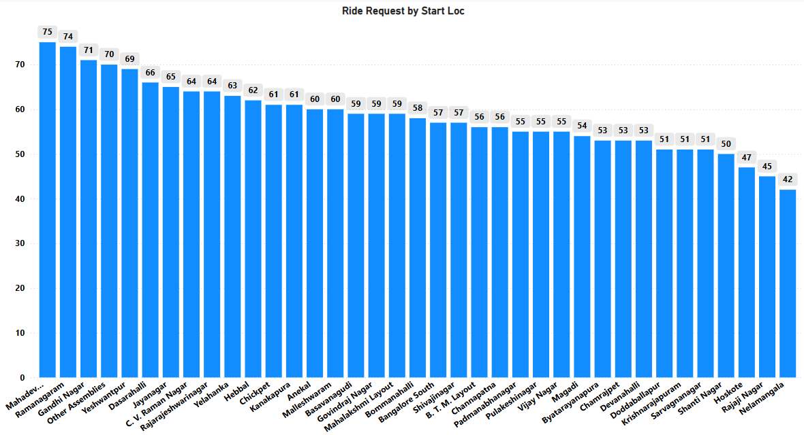
As per the bar chart ride requests by start location below are the top 5 zones with the highest number of ride requests.
Mahadevapura with 75 ride requests,
Ramanagara with 74 ride requests,
Ramagondanahalli with 71 ride requests,
Gandhi Nagar with 70 ride requests and,
Other Assemblies with 69 ride requests.

  - 2.6.2. Revenue: Identify pickup zones generating the highest revenue.
[3 marks]
Solution:

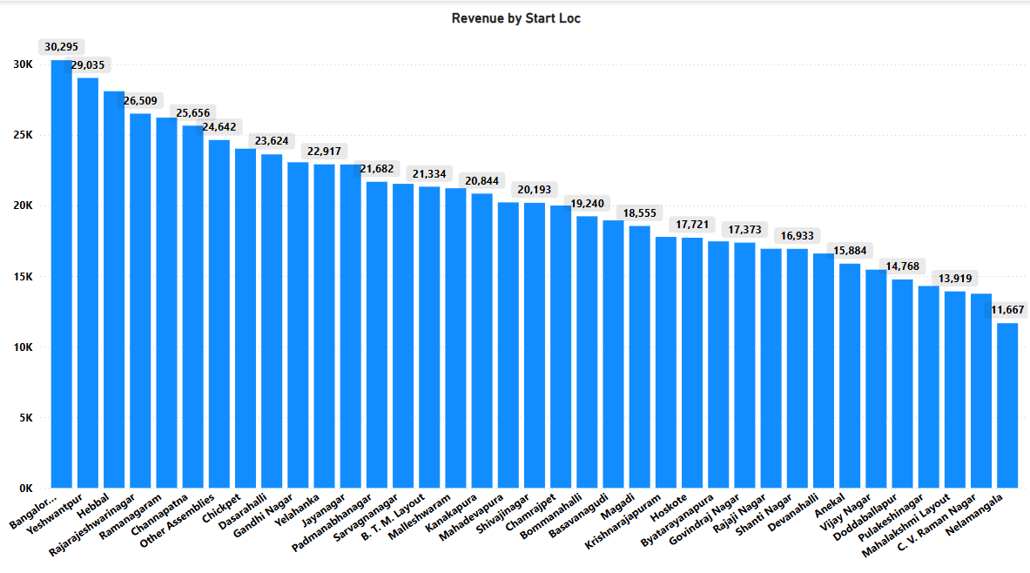
Based on the bar chart top 5 pickup zones generating highest revenue are as follows
Bangalore South with 30,295,
Yeshwanthpur with 29,035
Hebbal with 26,509
Rajarajeshwarinagar with 25,656
Ramanagara with 26,642

- Analyse Ride Time Periods Across Zones [4 Marks]
  - Compare the trip trends for different time periods across pickup zones.
Solution:

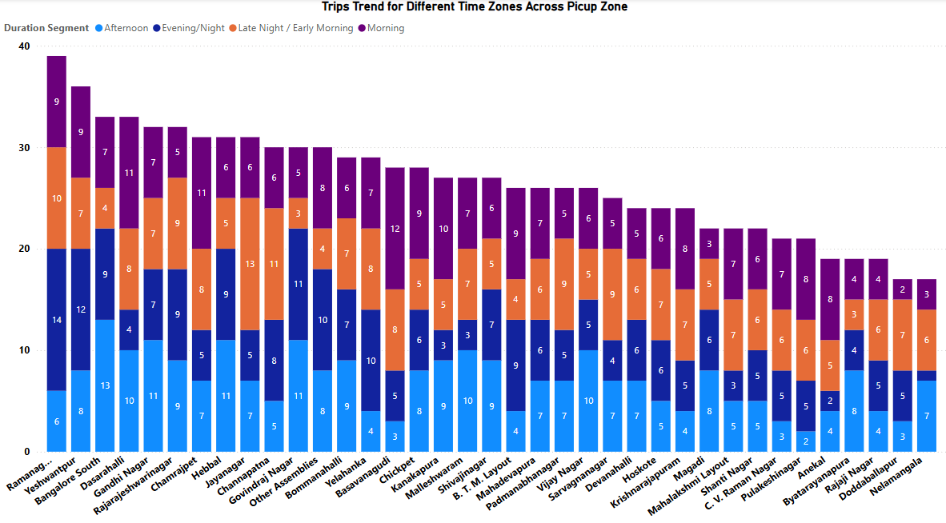
Ramanagara, Yeshwanthpur, Bangalore South is leading in total trip counts across all time periods.
These zones exhibit consistent activity across all four-time windows, especially high in Morning and Evening/Night.
This comparison helps pinpoint peak demand periods in each zone.
- Better fleet management and driver allocation
- Identifying untapped zones for promotional offers during low-demand periods
- Understanding user behaviour based on time of day

- Top Zones with Highest Trip Volume [3 Marks]
  - Identify the top 5 pickup zones with the highest total number of completed trips.
  - Analyse factors contributing to the higher number of trips.
Solution:

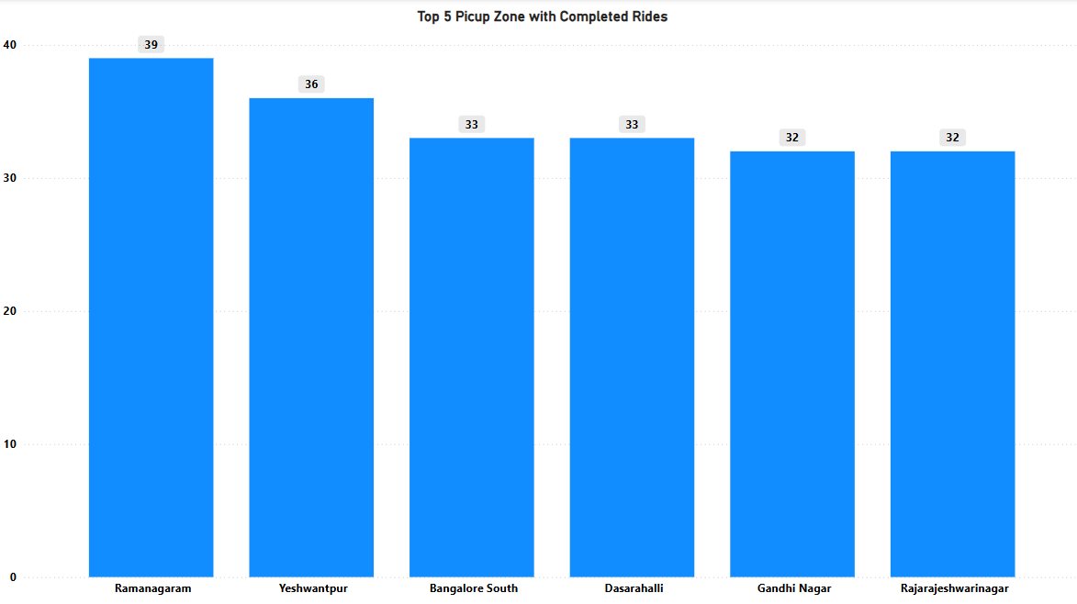
Ramanagaram, Yeshwanthpur, Bangalore South, Dasarahalli, Gandhi Nagar are the top 5 pickup zones with highest number of completed trips.
Below might be the factors of contributing highest number of completed trips.
- Possibility of a commuter hub or connecting point for long distance travelers.
- Major transportation hub with busy railway station or metro connectivity.
- Large residential and commercial mix, which fuels demand throughout the day.

- Basic Analytical Tasks [8 Marks]
  - 2.9.1
What are the percentages of cancellations and successful rides by both driver and customer? [3 marks]
Solution:

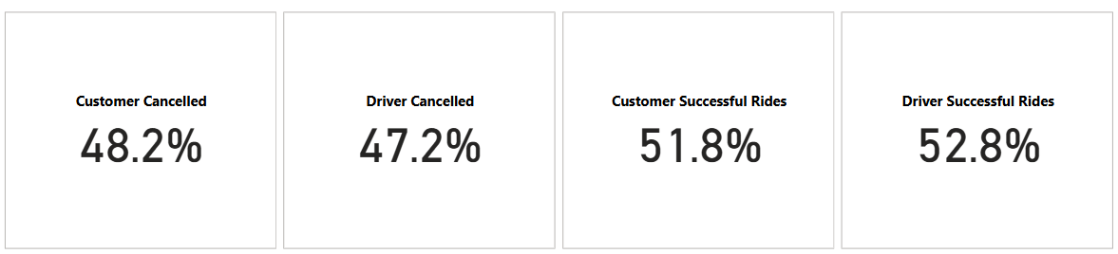
Customer Cancelled are 48.2% whereas Driver Cancelled are 47.2 %
Customer Successful Rides are 51.8% whereas Driver Successful Rides are 52.8%

  - 2.9.2
Analyse the percentage of people who completed trips after searching for quotes. Visualise the variation of this ratio by time periods.
[5 marks]
Solution:

- 100,000 quote searches, 65,000 completed rides → 65% conversion rate
- Conversion highest during 8–10 AM and 5–7 PM
- Funnel chart used to show drop-offs
- Line chart showed hourly variation in conversion

- Create a Parameter and Use Filters [5 Marks]
  - Create a parameter and use it as a filter on an appropriate subset of the data to interactively analyse and visualise different subsets of the data.
  - Explain your choice of filter and insights drawn from this step.
Solution:

Assembly can be used a filter which help to analyze the entire report with respective of each location.
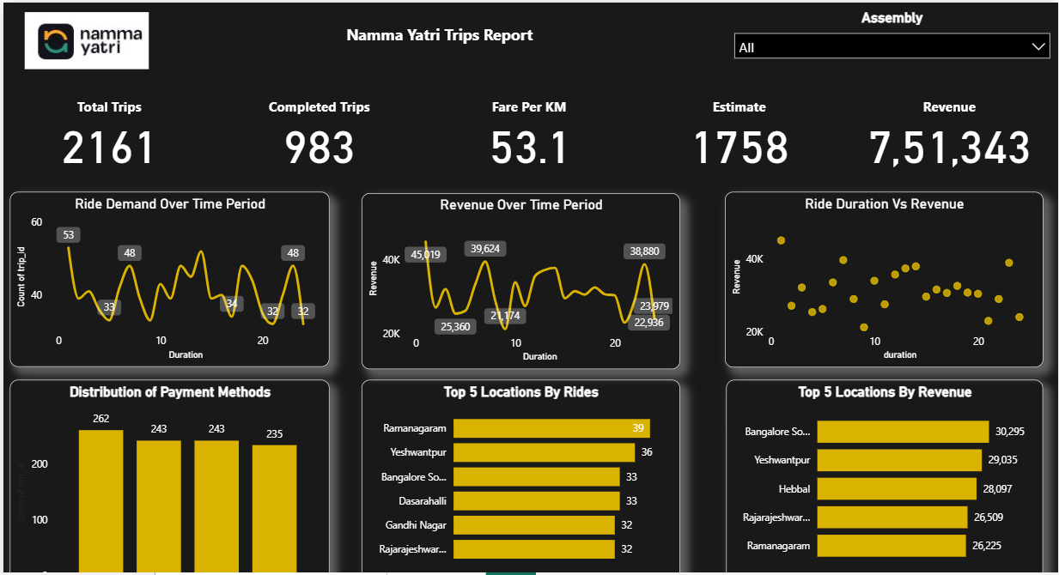

3. Conclusion [20 Marks]
- Recommendations for Operational Efficiency [10 Marks]
  - Based on your findings from the analysis, provide recommendations on how Namma Yatri can optimise its operations.
  - This could include strategies for improving resource allocation, reducing cancellations, or optimising ride durations.
  - Add supporting dashboards.
Solution:

1. Focus on High Demand zones for better resources allocation.
Findings:
Top pickup zones by request and completed trips include are (Ramanagaram, Yeshwantpur, Bangalore South, Dasarahalli, Gandhi Nagar.
These zones also show a consistently high number of requests across time segments, especially in Afternoon and Evening/Night.
Recommendations:
Deploy more drivers in the high demand zones during the peak time segments.
Introduce dynamic driver incentives to maintain supply in high demand hours.
Monitor the trends regularly to keep updated.
2. Improve Revenue by Targeting High – Potential Zones
Findings:
Zones like Bangalore South, Yeshwantpur, and Hebbal are generating the highest revenue.
These areas likely consist of longer ride durations.
Recommendations:
Offer premium ride packages in high revenue zones.
Consider fare optimization or upselling options in zones with frequent long-distance rides.

- Marketing and Operational Strategy Improvements [10 Marks]
  - Suggest improvements to Namma Yatri’s marketing or operational strategies based on your analysis.
  - Recommendations could involve promotional efforts, driver incentives, or regional targeting to increase customer satisfaction and service efficiency.
  - Add supporting dashboards.
Solution:

Marketing Strategy Enhancements
1. Geo-targeted Promotions in Low-Activity Zones
Findings:
Pickup zones like Nelamangala, Rajaji Nagar, Hoskote show low trip volume and revenue.
Recommendations:
Launch location-based promotions (e.g., first-ride discount, referral bonuses) in underperforming areas.
2. Peak Hour Ride Campaigns
Findings:
Trips are concentrated during Evening/Night and Afternoon slots.
Recommendations:
Promote Happy Hour Rides (discounts during off-peak slots like mornings or late nights).
Driver Incentive Program Optimization
Bonus Schemes in High-Demand Zones
Findings:
Zones like Mahadevpura, Ramanagram, Gandhi Nagar dominate both completed trips and trip volume.
Recommendations:
Provide extra incentives or bonuses to drivers operating consistently in these high-demand zones.
Retention Strategy for Off-Peak Hours
Findings:
Drop in trips during morning and late-night slots.
Recommendations:
Offer "off-peak ride" bonuses to drivers who log in during low-demand hours.

